09.09.
the longer my hands stayed there, the more i wished they were yours instead 👀
i dont think you wouldve covered quite as much
text me exactly what youd do once my hands were out of the way 😏
-> kann man machen
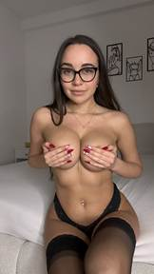
-> wird natürlich auch als Story-Bild verwendet. In dem Fall okay, in Zukunft drauf achten

14.09.
i went to the river for a little break and found the perfect rock to sit on 😇
then i started thinking about getting caught out there… and suddenly the water wasnt the only thing making me wet 😏
would you risk it with me? i even recorded a naughty tape out there, message me if you wanna see it ;)

- > haben masturbation content in dem Setting deswegen den CTA geaddet
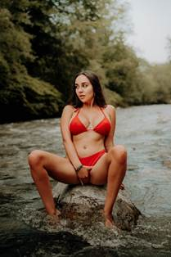
19.09
the workbench looked much more inviting than all the tools, so i made myself comfortable 🤭
bare feet werent exactly practical, but at least my manicure matched my pedicure

what job are you giving me?
hold the tools 🛠️
tease you with my feet 😏
Bild fehlt, kann man sonst aber safe so machen

24.09.
i never understood why anyone gets dressed just to relax at home 😇
this is much more comfortable… and the side view is better too
yes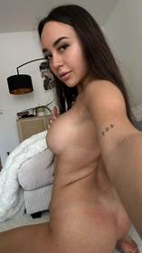
29.09.
you can always tell im in a good mood when the tongue comes out 😛
with a mirror that close to the bathtub, there was no chance i was taking a normal selfie
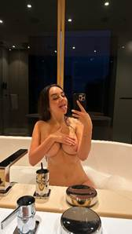
passt

